82. Component Event Real Time Scenario - 03 August 2022

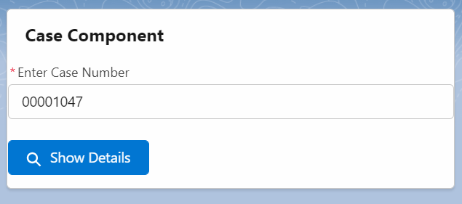

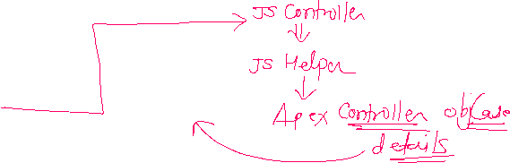

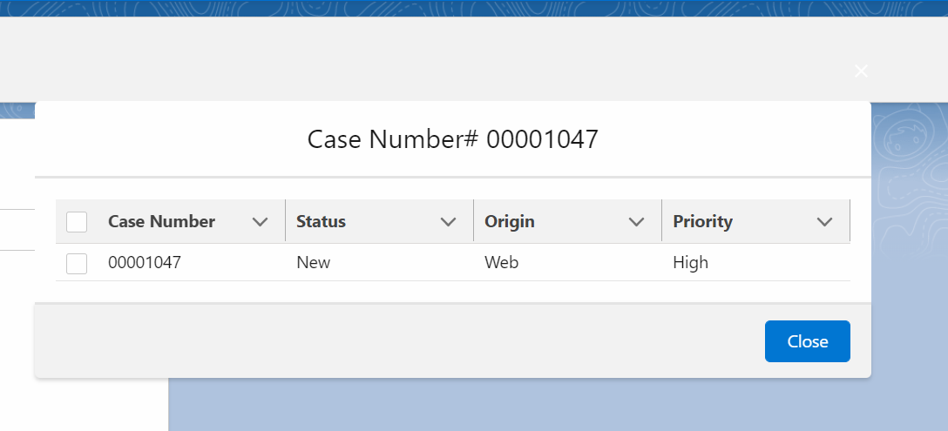

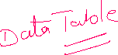

EVENT:

<aura:event type="COMPONENT" description="Event template">

<aura:attribute name="caseEventshowFlag" type="Boolean" />

</aura:event>

Case Component:

<aura:component controller="CaseProvider" implements="force:appHostable,flexipage:availableForAllPageTypes,flexipage:availableForRecordHome,force:hasRecordId,forceCommunity:availableForAllPageTypes,force:lightningQuickAction" access="global" >

<aura:attribute name="caseObject" Type="Case" default="{'sObjectType' : 'Case'}" />

<aura:attribute name="showPoupFlag" type="Boolean" default="false"/>

<aura:attribute name="caseList" type="List" />

<!--Handle Event-->

<aura:handler name="CaseEventRegistration" event="c:CaseEvent" action="{!c.closePopupController}" />

<lightning:card title="Case Component">

<lightning:input type="Text" label="Enter Case Number" value="{!v.caseObject.CaseNumber}" /> <br/>

<lightning:button variant="brand" iconName="utility:search" label="Show Details" onclick="{!c.showPopupController}" />

<!--Call CaseDetailsPopupModal-->

<aura:if isTrue="{!v.showPoupFlag}">

<c:CaseDetailsPopupCompo receivedCaseObject="{!v.caseObject}" receivedCaseList="{!v.caseList}"/>

</aura:if>

</lightning:card>

</aura:component>

JS Controller:

({

showPopupController : function(component, event, helper) {

helper.showPopupHelper(component, event, helper);

},

closePopupController : function(component, event, helper) {

console.log('Zatka Laga...!!');

component.set('v.showPoupFlag' , event.getParam("caseEventshowFlag"));

}

})

JS HELPER:

({

showPopupHelper : function(component, event, helper) {

var action = component.get('c.getCaseDetails');

action.setParams({'objCase' : component.get('v.caseObject')});

action.setCallback(this, function(response){

if(response.getState() === 'SUCCESS'){

console.log('success '+JSON.stringify(response.getReturnValue()));

component.set('v.caseList' , response.getReturnValue());

component.set('v.showPoupFlag', true);

}

else{

console.log('Locha, something went wrong');

}

});

$A.enqueueAction(action);

}

})

Case Popup Modal

<aura:component implements="force:appHostable,flexipage:availableForAllPageTypes,flexipage:availableForRecordHome,force:hasRecordId,forceCommunity:availableForAllPageTypes,force:lightningQuickAction" access="global" >

<aura:attribute name="receivedCaseObject" Type="Case" default="{'sObjectType' : 'Case'}" />

<aura:attribute name="receivedCaseList" type="List" />

<aura:attribute name="columns" type="List" />

<!--Register Event-->

<aura:registerEvent name="CaseEventRegistration" type="c:CaseEvent" />

<!--sYSTEM EVENT -->

<aura:handler name="init" value="{!this}" action="{!c.doInit}"/>

<lightning:card title="Case Details">

<section role="dialog" tabindex="-1" aria-modal="true" aria-labelledby="modal-heading-01" class="slds-modal slds-fade-in-open">

<div class="slds-modal__container">

<button class="slds-button slds-button_icon slds-modal__close slds-button_icon-inverse">

<span class="slds-assistive-text">Cancel and close</span>

</button>

<div class="slds-modal__header">

<h1 id="modal-heading-01" class="slds-modal__title slds-hyphenate">Case Number # {!v.receivedCaseObject.CaseNumber}</h1>

</div>

<div class="slds-modal__content slds-p-around_medium" id="modal-content-id-1">

<lightning:datatable

keyField="id"

data="{! v.receivedCaseList }"

columns="{! v.columns }"

hideCheckboxColumn="true"/>

</div>

<div class="slds-modal__footer">

<button class="slds-button slds-button_neutral" aria-label="Close" onclick="{!c.closePoupController}">Close</button>

</div>

</div>

</section>

<div class="slds-backdrop slds-backdrop_open" role="presentation"></div>

</lightning:card>

</aura:component>

({

doInit: function(component, event, helper) {

component.set('v.columns', [

{label: 'Case Number', fieldName: 'CaseNumber', type: 'text'},

{label: 'Status', fieldName: 'Status', type: 'text'},

{label: 'Priority', fieldName: 'Priority', type: 'text'},

{label: 'Origin', fieldName: 'Origin', type: 'text'},

{label: 'Created Date', fieldName: 'CreatedDate', type: 'Date'}

]);

},

closePoupController : function(component, event, helper) {

var myComponentEvent = component.getEvent("CaseEventRegistration");

myComponentEvent.setParams({"caseEventshowFlag" : false});

myComponentEvent.fire();

}

})

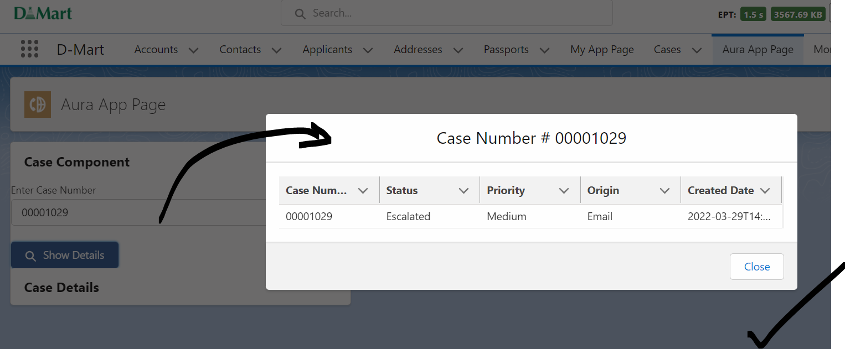

04 Aug : Aura Method

05 Event Propagation